Development tutorial for Sony Ericsson phones
Purpose
This page describes the installation, configuration of J2ME environment and how to install a dummy program in Michael’ cell phone (Sony Ericsson W300i)

Overview
1 Required Software
2 Installation
3 Configuration
4 Project
5 Deployment
6 Running

1 Required Software
The following software will be used:
Eclipse 3.2.2
EclipseME1.7.9
Sun Java wireless Toolkit 2.5.2
Sony Ericsson SDK 2.5.0.2 for the Java™ ME Platform
Sony Ericsson PC Suite

2 Installations
Install Eclipse as usual
Install Sony Ericsson PC Suite as usual
Install Sun WTK as usual
Install Sony Ericsson SDK as usual
Install EclipseME plugin: tutorial is here ( http://eclipseme.org/docs/installation.html)

3 Configurations
Check that Eclipse->Windows-Preferences contains "J2ME" entry.
Choose Device Management, select Import Devices.
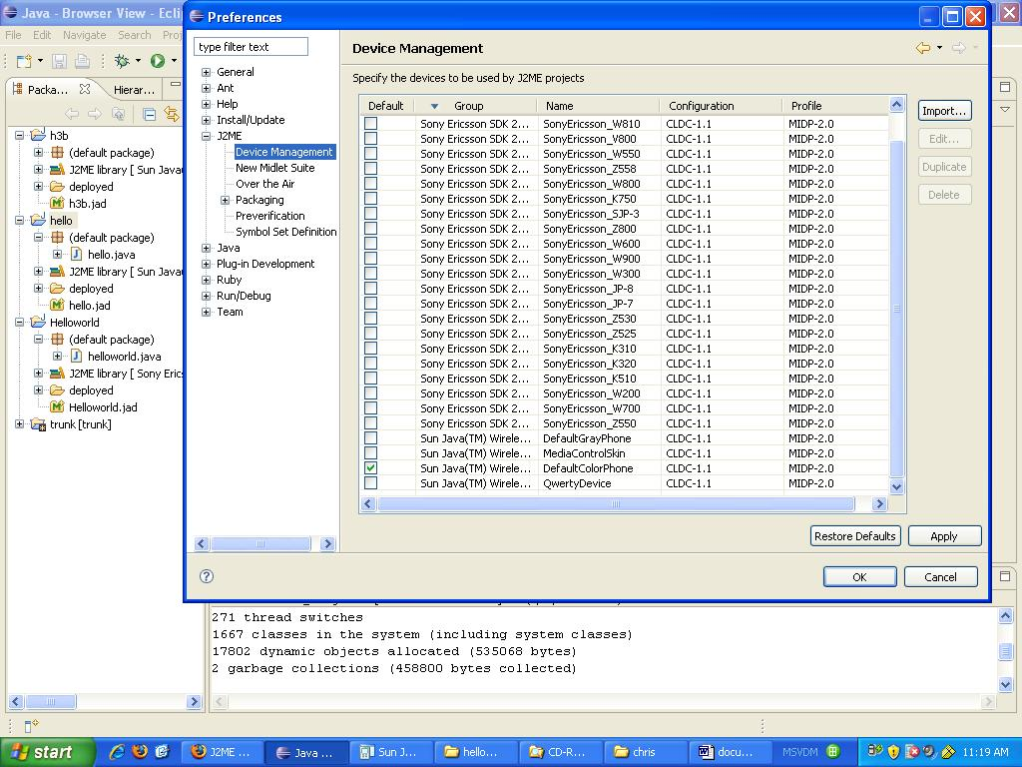
Select the path to Sun WTK and Sony Ericsson directory. Click refresh then add them.
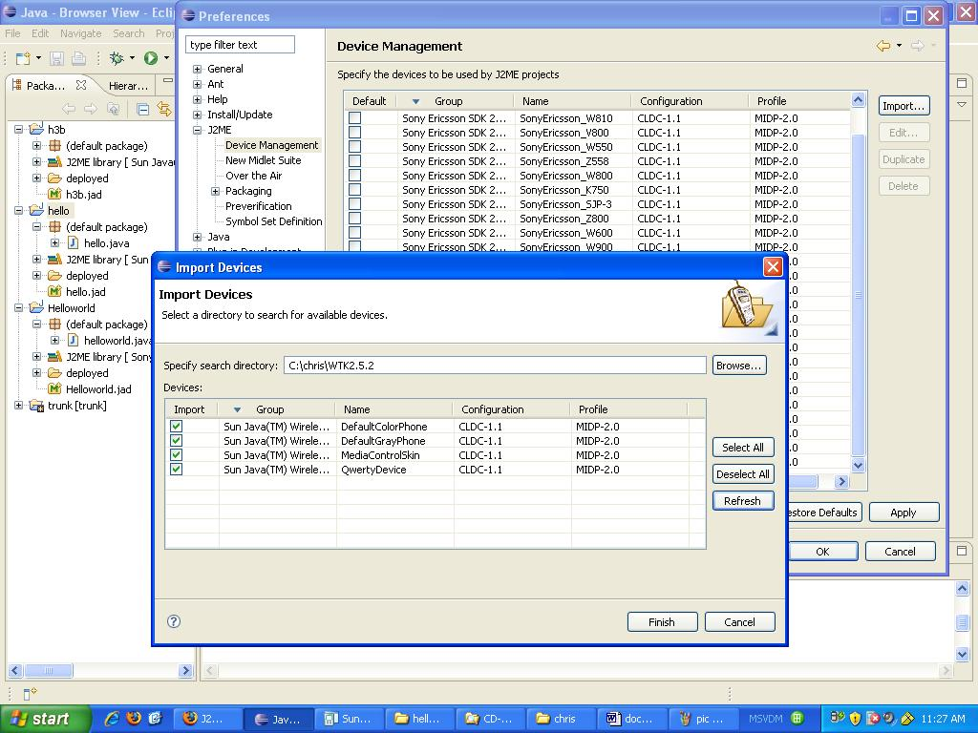

4 Project
Select File -> New ->Project.-> J2ME-> J2ME Midlet Suite. Set path and project name.

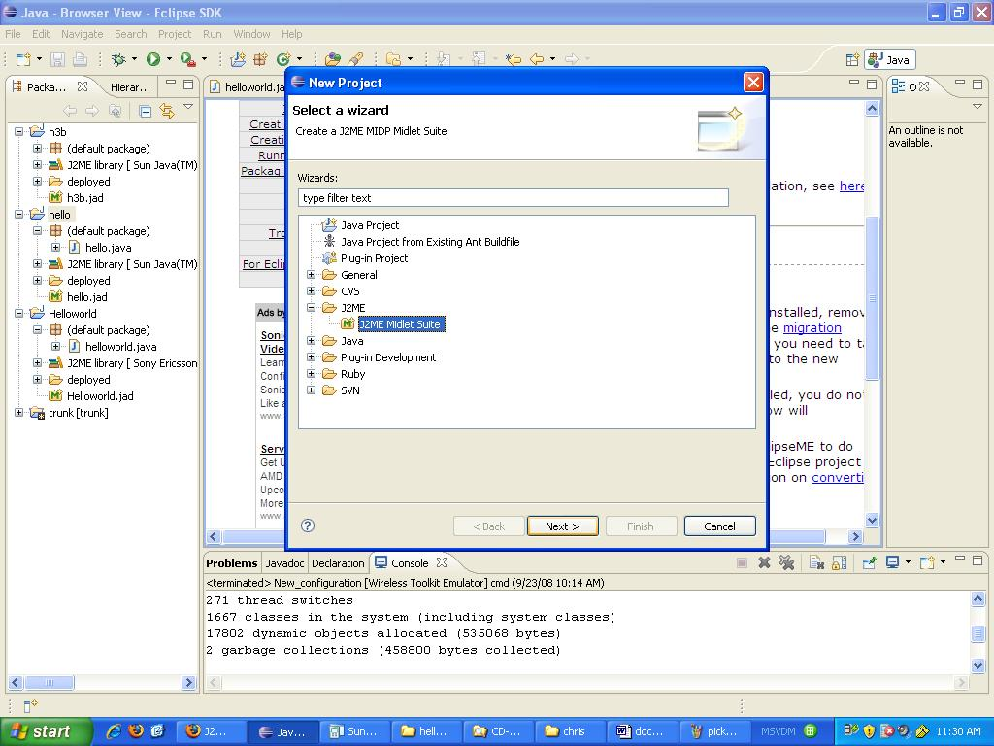

Right click your project name, select New->other-> J2ME Midlet Give it a name (HelloWorld)
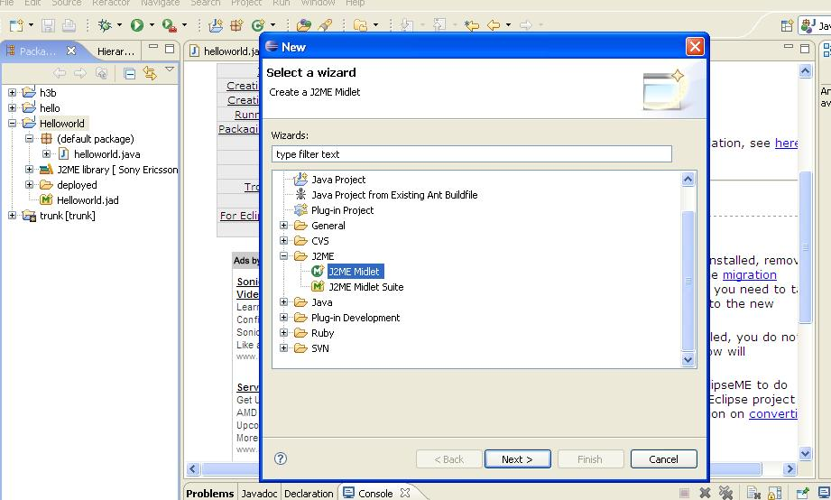

Copy and paste the Hello World code:

import javax.microedition.lcdui.Display;
import javax.microedition.lcdui.TextBox;
import javax.microedition.midlet.MIDlet;
import javax.microedition.midlet.MIDletStateChangeException;
public class helloworld extends MIDlet {
private TextBox textbox;
public helloworld() {
super();
textbox = new TextBox("testing","Hello World!", 20, 0);
}
protected void startApp() throws MIDletStateChangeException {
Display.getDisplay(this).setCurrent(textbox);
}
protected void pauseApp() { }
protected void destroyApp(boolean arg0) throws MIDletStateChangeException {
}
}

Choose “Run”->Run. Select Wireless Toolkit Emulator(double click it or right click choose “New”)
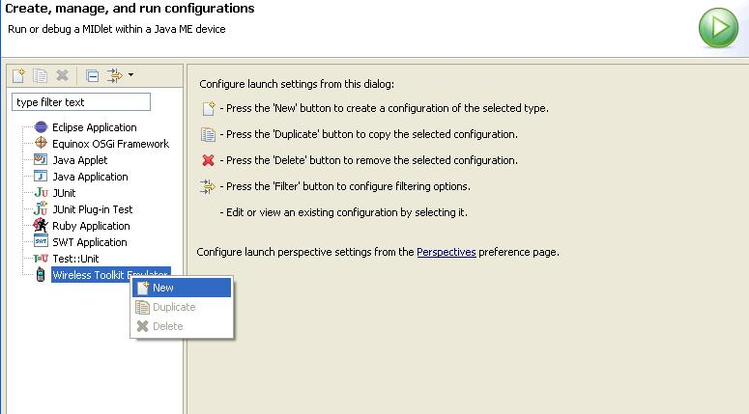

Select New_configuration (or you named it) Midlet page->select your project
Emulation page-> Specific Device ->Select your group (Sony Ericsson SDK or Sun WTK). If you don’t have a Sony Ericsson cell phone, you have to use Sun WTK test it, then select Device->DefaultColorPhone. It will show a picture as follow. If you want test it with Sony Ericsson phone, connect phone to computer with USB cable, choose “Phone Mode”(it will not run if choose “File Transfer”). Then, back to eclipse, select Sony Ericsson SDK, select Device-> your phone.
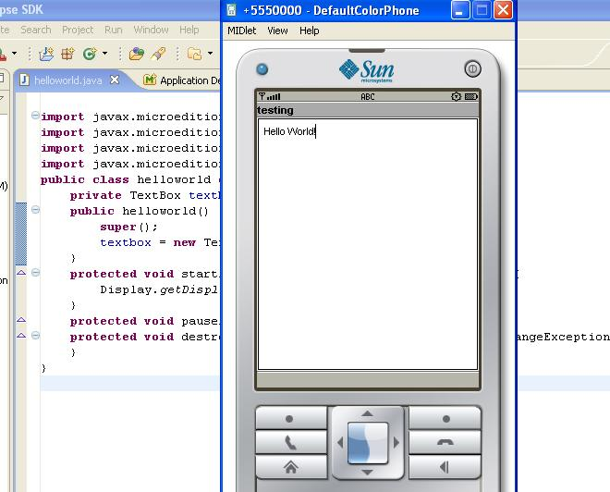

5 Deployment
Now, we need run Helloworld in the cell phone. First, we need get Jar&Jad file. Right click on the project, select J2ME->create package. A new sub-directory (deployed) will appear. It contains a jar files (which contains your classes) and a jad file (which contains the description of your midlet).

6 Running
Use USB cable to connect cell phone(W810i) with computer. Select file manager, wait a second; the computer will find a removable disk. Select new disk->others, copy jar&jad files to this folder. Use Safely Remove Hardware remove cell phone disk. Plug out USB cable. Open cell phone->File Manager->others->hello world file->install ->choose a folder. Then you can run it. Keep pushing “back” key to quit the program.

Links:
Sun Java Wireless Toolkit 2.5.2 for CLDC Download
http://java.sun.com/products/sjwtoolkit/download.html

Sony Ericsson W810i PC suite
http://www.sonyericsson.com/cws/support/softwaredownloads/detailed/pcsuite/w810i?cc=ca&lc=en

Sony Ericsson SDK 2.5.0.2 for the Java™ ME Platform
https://developer.sonyericsson.com/site/global/docstools/java/p_java.jsp

EclipseMe installation
http://eclipseme.org/docs/installation.html

J2ME development environment
http://www.autexier.de/jmau/dev/j2me/j2me.html

